ZSight – Geolocation logic alignment and workflow



Document ID | DigDev_ZSight_Geolocation_Logic_FDD_v1.0
Product | Zsight
Environment | All
Confidentiality Level | Internal / Restricted

Contents
1 DOCUMENT INFORMATION 3
1.1 Validation 3
1.2 Document Distribution 3
1.3 Version Control 3
2 PREFACE 4
2.1 About this document 4
2.2 Related documents 4
2.3 Who should read this document 4
2.4 Terminology 4
2.5 Conventions Used 5
3 GEOLOCATION MODEL 7
3.1 Overview 7
3.2 Field Model 8
3.2.1 Geofence reference – the expectation 8
3.2.2 Assessed location – the observation 9
3.2.3 Active geofence reference 9
3.2.4 Geofence boundary 9
3.3 User Roles 10
4 SYSTEM LOGIC AND WORKING PROCEDURES 11
4.1 Container Status Lifecycle 11
4.2 Device Report Evaluation 11
4.3 Notification Lifecycle 13
4.4 Apply Manual Geolocation Override 14
4.4.1 Procedure 14
4.5 Archive a Container 14
4.5.1 Procedure 14
4.6 Null and Staleness Rules 15
5 APPROVAL SIGNATURES 16

DOCUMENT INFORMATION

Validation
Name |  | Role | Date (dd/mm/aa)
Issued by | Oscar Rondon | Technical Writer | 05/08/2026
Verified by | Ezequiel Garcia | Developer | 03/08/2026
Approved by | Anthony Bures | Digital Development Manager | 05/08/2026

Document Distribution
Normal | Role
Oscar Rondon | Technical Writer
Anthony Bures | Digital Development Manager
Ezequiel Garcia | Developer

Version Control
Version | Date | Author | Description of changes
1.0 | 05/08/2026 | Oscar Rondon | 1st version of the functional design document for the geolocation logic workflow in ZSight.

PREFACE

About this document
This document defines the geolocation logic used by ZSight to determine where a monitored container is, to compare that position against where it is expected to be, and to raise a geofence violation when the two diverge beyond an accepted threshold.
It exists to give development, QA, support and business stakeholders a single agreed description of that logic before further development continues.

Related documents
All documents or elements used for reference are presented in the following table:
Title | Reference | Author | Version
UGU | ZSight User Guide | Oscar Rondon | 1.0

Who should read this document
This document is written for readers who need to understand why ZSight reports a container's position as it does, rather than how to operate the interface.
- Developers and QA engineers implementing or testing geolocation behavior, particularly the reference selection and evaluation rules.
- Customer support and implementation specialists investigating geofence violations, distinguishing genuine relocation from GPS drift, and deciding whether a manual override or an archive is the correct response.
- Business stakeholders and product owners validating that the described logic matches intent before further development proceeds.
Readers who need to know how to navigate the application, locate a container, or read the notifications list should refer to the ZSight User Guide instead. Shared table behavior — filtering, searching, exporting and column selection — is documented once in the User Guide's Overall System Functionalities section and is not repeated here.

Terminology
Term Used | Description
Archive | The action that retires a container from operations and stops feed processing. Set in the Edit Container view with a reason. Existing geolocation data and notification history are retained.
Assessed Location | The group of device-derived positions describing where a container is now, as opposed to where it is expected to be.
Calculated Location | A stabilized point computed over recent valid fixes using a short window. Smooths out variation between individual readings. The preferred observation for violation checks.
Container | A monitored waste container. The record that geolocation fields belong to.
Container Location | The container's position on a given feed, referred to in development as Point B. Resolved by priority from Current, Estimated, Ref 2, Ref 1, and finally the device's last known coordinate. Always resolves to a value, so every feed carries a position.
Current Reading | The latest raw GPS fix reported by the device. Nullable, and frequently null – a report only carries a fix when satellite coverage allows. Serves as the fallback observation when no stable Calculated Location exists.
Daily Feed | The record created from a single device report. A point-in-time snapshot of what one message carried.
DEMA | Double exponential moving average. The calculation used to derive Ref 2 from accumulated device fixes.
Device Report | An inbound message from a container’s device, received on the asset feed endpoint. May or may not carry a GPS fix.
Estimated | A container position received in the feed, used as the Container Location when no Current coordinate is present.
Expectation | Where a container is understood to belong. Represented by the Active Geofence Reference.
Evaluation radius | The 150 m radius drawn around the Reference Point. A container is in violation when its Container Location falls outside this radius. A fixed global value, not configurable per site.
Fix | A GPS position obtained by the device. Requires satellite coverage; its absence is normal operation rather than an error.
Geofence Reference | The group of stored reference points, Ref 0, Ref 1, Ref 2 and Manual Override, each preserved with its coordinate, source, created date and status.
Geofence Violation | The notification raised when the distance between the observation and the Active Geofence Reference exceeds the movement threshold.
GPS-stale review | A data-quality review raised when no valid fix has been received for a configured number of days. Suppresses movement alerts. Distinct from Device Offline, since a device without satellite coverage may still be reporting images and sensor data normally.
Manual Geo Location | The override marker and its coordinates, set in the Edit Container view. Becomes the Reference Point only while its status is active.
Manual Override | An expected coordinate set explicitly by an authorized user, either by selecting a point on the map or by entering the values directly. Applied when its status is set to active, at which point the coordinates currently held in the latitude and longitude fields are committed. While active it outranks every system-generated reference and is never removed automatically.
Map Mode | The container details view that displays the geofence boundary as a circle around the active reference, with the container's assessed position marked separately.
Reference Point | The expected position a container is measured against, referred to in development as Point A. Resolved from two values only: the Manual Geo Location coordinates when the override status is active, otherwise the Site Location coordinates.
Ref 1 – Install Reference | A container position received in the feed, first available at installation. The first point at which the container's exact position is known. Contributes to the Container Location, not the Reference Point.
Ref 2 – Stabilized Device Reference | A DEMA-averaged container position received in the feed. Contributes to the Container Location, not the Reference Point.
Site | A customer location containing one or more containers. Supplies the service address from which Ref 0 is geocoded.
Site Location | Geocoded coordinates of the site service address. Created with the site record, before any container exists, and held internally in ZSight. Sent to the device provider when a container moves from Created to Inactive. A physical address, so it does not change. Serves as the default Reference Point.
Work Order | The record grouping containers for an operational activity. Currently limited to the installation type.

Conventions Used
The following structures are used as recommendations.
Info: Supplementary Information

Tip: A recommendation or useful advice

Warning: A warning or important notice

Note: A notice.

GEOLOCATION MODEL

Overview
ZSight monitors waste containers fitted with cameras and IoT devices. Each device sends periodic reports containing container data and, when satellite coverage allows, a GPS position. Geolocation determines whether a container is within an acceptable distance of where it is expected to be. It does this by comparing two values on each device report:
Value | Definition | Derived From
Reference Point | Where the container is expected to be | The Site Location, or the Manual Geo Location when active
Container Location | Where the container is on this report | Coordinates received in the feed
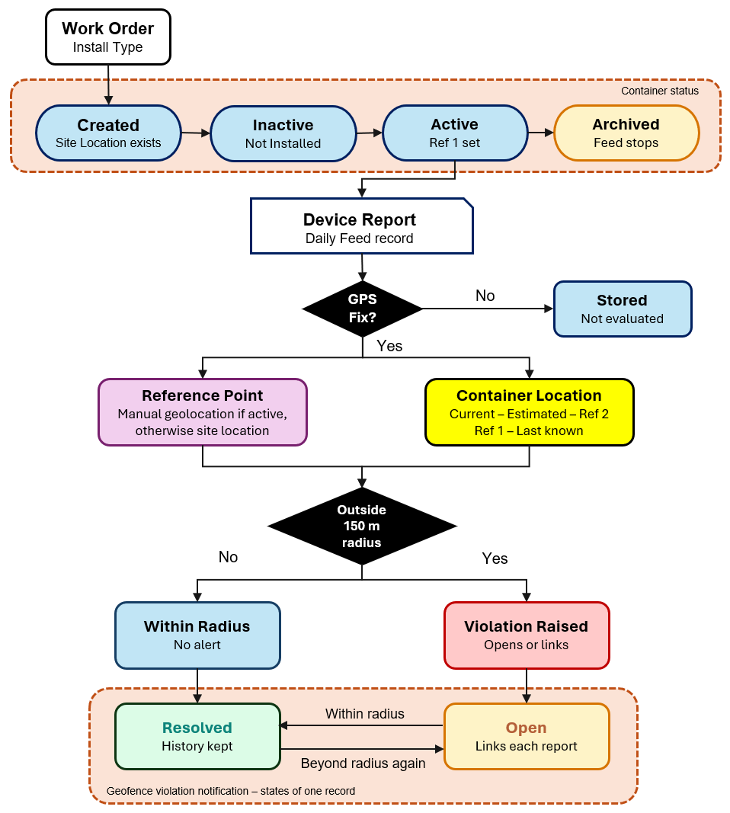
A geofence violation is raised when the distance between the two exceeds the configured movement threshold. No single stored coordinate represents a container’s position. Four separate reference points may exist, and which one is used depends on what is available:
- The geocoded service address is a street address, which on a large site may sit some distance from the container.
- The installer’s recorded position is captured once, at activation.
- The stabilized reference requires roughly 30 days of accumulated readings before it becomes available.
- A manual override exists only when a user has explicitly set one.
The expectation therefore changes as a container ages. A newly created container has only its geocoded address. After installation it also has the installer’s position. After approximately a month it has a stabilized reference, which takes precedence over both. Two containers under identical conditions can evaluate differently because of this.
Note: A manual override changes where the system expects a container to be, and applies to a reference point that was never accurate. A container that has genuinely moved should be archived instead, since an override would conceal the movement rather than record it.

Field Model
Geolocation data is held in two groups. Each group resolves to a single value on evaluation, and the comparison, and the comparison between those two values is what produces or clears a geofence violation.
Group | Contains | Answers
Reference Point | Site Location, Manual Geo Location | Where the container is expected to be
Container Location | Current, Estimated, Ref 2, Ref 1, last known coordinate | Where the container is on this report

Both groups appear under Location & geofence on the container details page. Any individual value may be empty. References populate over time rather than all at once, so a container’s geolocation data is expected to be partially complete for a period after creation.
Note: Interface labels do not map one to one onto the field names defined in this section.

Geofence reference – the expectation
Four reference points may exist for a container. Each is stored with its coordinate, source, created date and status, and each is preserved rather than overwritten when a stronger reference becomes available.
Reference | Source | Created | Can be absent
Ref 0 – Address | Geocoded from the site service address | At container record creation | No
Ref 1 – Install | The installer’s mobile GPS position | At device activation | Only if capture failed
Ref 2 – Stabilized | DEMA over approximately the last 100 device readings | After roughly 30 days of accumulated readings | Yes, until sufficient history exists
Manual Override | Coordinates entered or selected by an authorized user | On demand | Yes, unless one has been set

- Ref 0 is geocoded from a street address. On a large site this may place the reference some distance from the container’s physical location, which is the most common cause of persistent false-positive violations on containers that have not yet accumulated a stronger reference.

- Ref 1 is captured once and is not updated by later reports.

- Ref 2 is a long-window average describing where a device habitually sits. Because the window spans roughly a month, it responds slowly to a genuine relocation by design.
Info: Ref 2 and the calculated location are both averaged values and are not interchangeable. Ref 2 uses a long window and answers where a device lives; the calculated location uses a short window and answers where it is now. Ref 2 is the anchor being measured against, and the calculated location is the value being measured.

Assessed location – the observation
Two values describe a container’s current position.
Field | Source | Can be absent
Current Reading | The latest raw GPS fix reported by the device | Yes, and frequently is
Calculated Location | Stabilized over recent valid fixes using a short window | Yes, until enough readings accumulate

The current reading is null whenever a report arrives without a GPS fix, which depends on satellite coverage and occurs routinely. The calculated location holds its last value and timestamp between fixes. It does not decay or drift on its own.
The calculated location is the preferred observation because it absorbs the variation between individual readings. A single distant fix shifts it only slightly, while a sustained change in position moves it within a few readings.

Active geofence reference
The active geofence reference is a derived value that identifies which of the four references is currently in force. It is re-derived whenever its inputs change and is the expectation used in every comparison.
The rule returns the first match, evaluated from top to bottom. A manual override takes precedence whenever its status is active, regardless of what other references exist. Ref 2 continues to be calculated in the background while an override is in force but does not displace it.
Because Ref 2 becomes available only after sufficient history has accumulated, a container’s active reference typically changes at least once during its first month of operation – from Ref 1 to Ref 2 – without any user action.

Geofence boundary
The boundary is a radius centered on the active geofence reference. A container is within tolerance when the distance between its observation and that reference falls at or below the configured movement threshold.

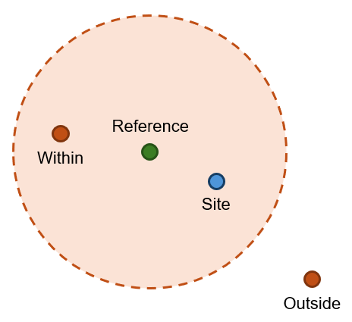

Symbol | Key | Meaning
 | Manual geo location | The reference point here
 | 150 m radius | Drawn around the reference point
 | Site location | Present but not used while override is active
 | Container location | Resolved on each report

The boundary moves with the active reference. When a container’s active reference changes, for example when Ref 2 matures and replaces Ref 1, the boundary is recentered on the new reference. A container that was previously outside the boundary may fall within it as a result, with no change in its physical position.
Container details display the current outcome as a Within Boundary indicator together with the measured distance from the reference. In Map Mode the boundary is drawn as a circle around the reference, with the container’s assessed position marked separately, allowing both values to be compared visually.
Note: The evaluation that applies this boundary, and the notification raised when it is exceeded, are described in sections 4.2 and 4.3.

User Roles
Most geolocation data is system-generated and requires no user action. Two operations are user-initiated, and both are performed in the Edit Container view.
Description | Standard User | Administrator
View container geolocation data on the container details page | 
View the geofence boundary and container position in Map Mode
View geofence violation notifications
Access the Edit Container view | Permission-based
Set or clear a manual geolocation override | Permission-based
Archive a container | Permission-based

Where a user does not have edit permission for a container, the edit icon is not displayed on the container details page, and the Edit Container view cannot be reached.
Note: This section is mandatory for all applications with role-based access.

Warning: Edit permission has been observed to differ between accounts for the same signed-in user. Whether the permission is assigned globally or per customer account is unconfirmed.

SYSTEM LOGIC AND WORKING PROCEDURES
This section describes the behavior of the geolocation feature, the states a container moves through, the evaluation performed on each device report, the lifecycle of the resulting notification, and the two manual procedures available to users.

Container Status Lifecycle
The Status field on the container record has four values. The system sets them automatically, with the exception of archiving, which is a manual action. A container remains in each state until an event moves it.
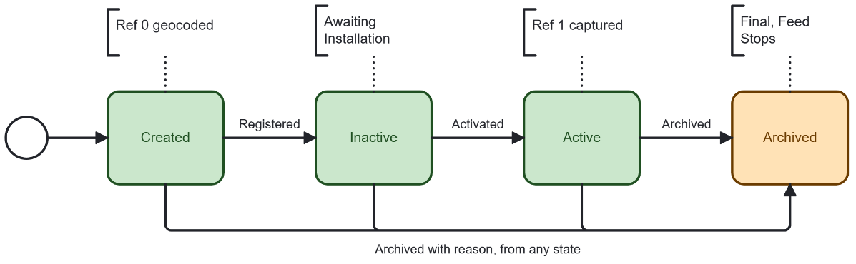
Status | Meaning | Set When | Geolocation data present
Created | Record exists and is being registered with the device provider. | Container record is created from a work order. | Ref 0 only
Inactive | Awaiting physical installation. A device may be tentatively assigned, but the technician is not restricted to it. | Registration with the provider completes. | Ref 0 only
Active | Installed and transmitting | A technician mounts and activates the device on site. | Ref 0, Ref 1, and accumulating readings
Archived | Retired from operations. Feed processing stops. | A user archives the container and selects a reason. | Retained, no longer updated
Archiving is reachable from every state, including before installation. A container may be archived without ever having been installed – for example when the customer becomes inactive between provisioning and deployment.
Note: Container status is distinct from device status. A container in the Active state may still have a device that is offline or without satellite coverage. Device conditions are reported separately through the notifications module.

Device Report Evaluation
This is the core runtime process. It is triggered by each device report received on the asset feed endpoint and always terminates in one of three outcomes: the report is stored without evaluation, the evaluation falls within tolerance, or a geofence violation is raised.
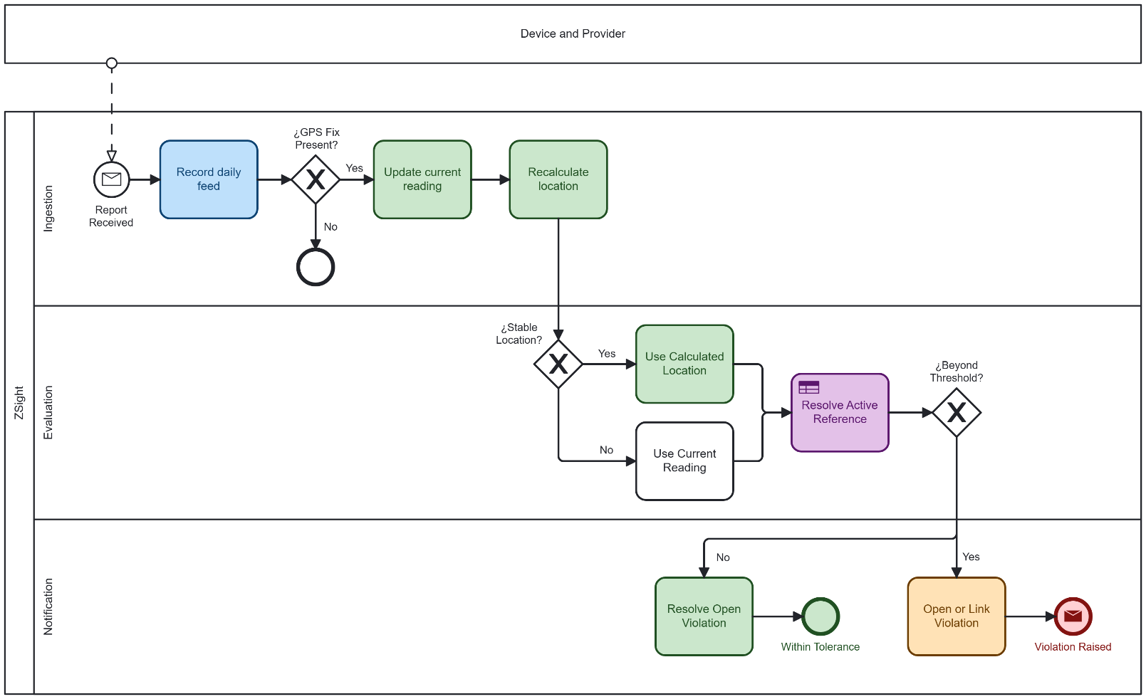
- Ingestion: Every report is recorded as a Daily Feed entry regardless of its contents. The process then checks whether the report carries a GPS fix. A report without a fix is normal operation, not an error. Satellite coverage is not always available, and many reports carry no position. When this occurs, the current reading is left unchanged, the process ends, and no alert of any kind is raised. Prolonged absence of fixes is handled separately – see section 4.6.

- Evaluation: When a fix is present, the current reading is updated with the raw position, and the calculated location is recalculated over the recent window. The process then selects an observation:
Condition | Observation used | Confidence
A stable calculated location exists | Calculated location | Normal
No stable calculated location | Latest current reading | Lower – flagged

The fallback applies when too few readings have accumulated, typically shortly after installation or following a reset after an extended outage. It keeps the check running rather than leaving the container unevaluated. In parallel, the active geofence reference is resolved by the rule defined in section 3.2.3.
- Comparison: The distance between the observation and the active geofence reference is compared against the movement threshold.

- Outcome: Within tolerance, any open violation for the container is resolved and the process ends. Beyond the threshold, a violation notification is opened, or the report is linked to an existing open notification.
Info: The behavior of a single distant reading differs by mode. Where a stable calculated location exists, one distant fix only shifts the smoothed point slightly and does not trigger a violation on its own; a genuine relocation still surfaces within a few readings. In fallback mode the single reading is the observation, so one anomalous fix can trigger the comparison by itself. Mitigation for this case is undecided.

Notification Lifecycle
Raising a geofence violation is an event within the evaluation process. What happens afterwards is the notification moving between two states, driven by subsequent evaluations rather than by user action.
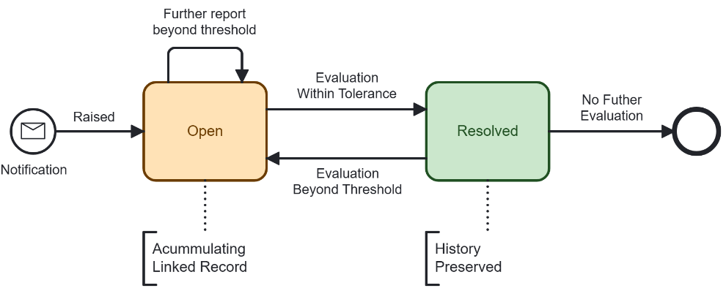
Status | Meaning
Open | The container has been measured beyond the movement threshold and has not since returned within tolerance.
Resolved | A later evaluation fell within tolerance. The record and its linked history are preserved; only the status changes.
Three behaviors follow from this model:
- Further violations do not create new notifications. While a notification is open, subsequent reports beyond the threshold link to the existing record rather than opening another. The first linked record carries the TRIGGER marker.
- Resolution is automatic. No user action closes a geofence violation. The status changes when a later evaluation falls within tolerance.
- Resolved is not terminal. A subsequent evaluation beyond the threshold reopens the same notification.
The distance can return within tolerance in three ways:
- The container physically returns, and the calculated location follows it within a few readings.
- Ref 2 matures and becomes the active reference, replacing an address or install reference that was never accurate.
- An authorized user sets a manual override placing the expectation at the true position.
Note: A maximum of 20 linked feed records are displayed per notification. Remaining records are retained but not rendered. The selection currently shows the oldest records.

Apply Manual Geolocation Override
A manual geolocation override sets an expected coordinate explicitly. While active it takes precedence over every system-generated reference. Ref 2 continues to calculate in the background but does not displace it.
The field is labelled Manual Geo Location in the Edit Container view and appears as Manual Override in the geofence reference table on the container details page.
- When to Use: Ref 0 and Ref 1 have proven insufficient to eliminate repeated false-positive geofence notifications, and the container’s true position can be confirmed, for example through satellite imagery.
- When Not to Use: The container has genuinely moved. An override in that situation conceals the movement rather than recording it. Archive the container instead.

Procedure
- Open the container from the Containers module to display the container details page.
- Select Map Mode to view the container’s position relative to its geofence boundary.
- Select the edit icon, located to the left of the gallery and map mode icons.
- In the Edit Container view, scroll to the Manual Geo Location sections.
- Set the coordinates by either method:
- Select Toggle Map to display the map, then select the point where the container is actually located. The latitude and longitude fields update to the selected position.
- Enter the values directly in the Latitude and Longitude fields.
- Set the Status toggle to active.
- Select Save.
Steps 5 and 6 can be completed in either order. The status toggle records that an override is active; it does not restrict when the coordinates can be set. Selecting Cancel at any point discards all changes, including any map selection already made.
The override remains active until a user sets the Status toggle back to inactive. It is never removed automatically. Setting the Status toggle to active applies whatever values are currently held in the Latitude and Longitude fields. Verify the coordinates before activating.
Warning: This functionality is permission-based. Where the signed-in user does not have edit permission for the container, the edit icon is not displayed on the container details page and the Edit Container view cannot be reached.

Archive a Container
Archiving retires a container from operations and stops feed processing. It is the correct response to a container that is no longer at its recorded site.
- When to use: The container has physically moved to a different location, has been removed from service, or the device has been lost or stolen.

Procedure
- Open the container from the Containers module to display the container details page.
- Select the edit icon, located to the left of the gallery and map mode icons.
- In the Edit Container view, scroll to the Archive section.
- Select a Reason from the list.
- Where Other is selected, enter the details in the field that appears.
- Set the Status toggle from Unarchived to Archived.
- Select Save.
Selecting Cancel at any point discards all changes.
Reason | Applies When
Container Change | The container is being replaced or exchanged at the same site.
Customer Inactive | The customer account is no longer active.
Temporary | The container is out of service for a limited period.
Permanent | The container is permanently removed from service.
Other | None of the above applies. A free-text details field is displayed for explanation.

Existing geolocation data and notification history are retained. The container no longer processes incoming reports.
Note: Both the manual geolocation override and the archive action are set in the same Edit Container view and saved by the same Save button. Take care not to modify one while intending to change only the other.

Null and Staleness Rules
These conditions determine when the evaluation described in section 4.2 is skipped, degraded, or escalated to a data quality review rather than a movement alert.
Condition | System Behavior | Outcome
Report carries no GPS fix | Current reading is not updated. Expected behavior, since a fix depends on satellite coverage. | No alert
Between fixes | Calculated location holds its last value with its original timestamp. It does not decay or drift. | No alert
No valid fix for the configured number of days | Calculated location is marked stale. Movement alerts are suppressed, since a stale position must not raise violations. | GPS-stale review
Fewer than the minimum number of valid fixes | No stable calculated location exists. The latest current reading is used, flagged as lower confidence. | Evaluation runs, degraded
One distant fix, stable calculated location exists | The reading shifts the smoothed point slightly. | No alert
One distant fix, fallback mode | The reading is the observation and can trigger the comparison alone. | May raise a violation

Info: A GPS-stale review is a data-quality condition, not a device failure. It is distinct from Device Offline — a device without satellite coverage may continue to report images and sensor data normally.

APPROVAL SIGNATURES
Digital signature blocks below are formatted for DocuSign / Adobe Sign.
Name | Role | Digital Signature Block | Date (dd/mm/aa)
Approval’s name | Approval’s role |  | 05/08/2026

--- END OF THE DOCUMENT ---

